**WEEK 34 GRADE2- Monday, May 10th , 2021**

**REVIEW 1**

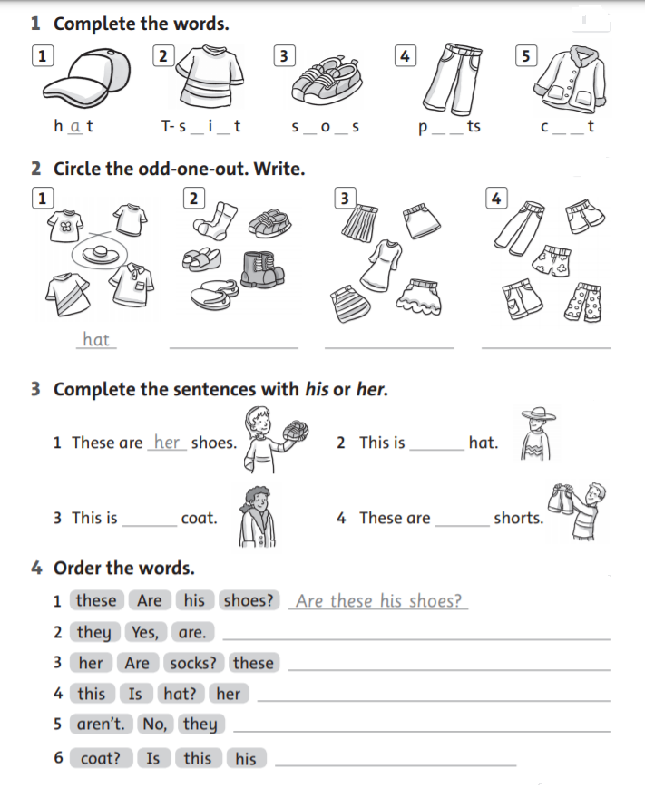

**WEEK 34 GRADE2- Tuesday, May 11th , 2021**

**REVIEW 2**

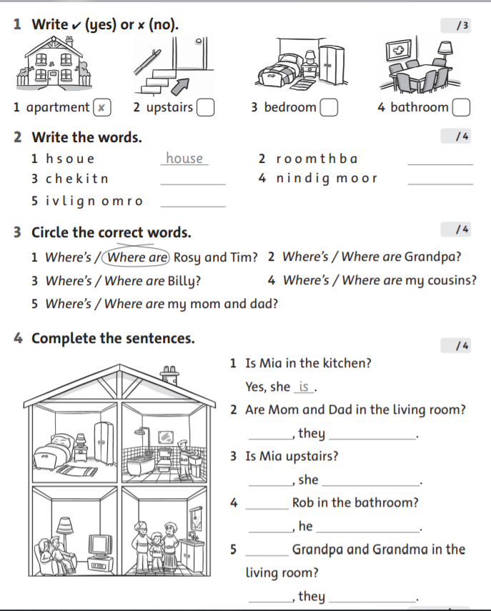

**WEEK 34 GRADE2- Wednesday, May 12th , 2021**

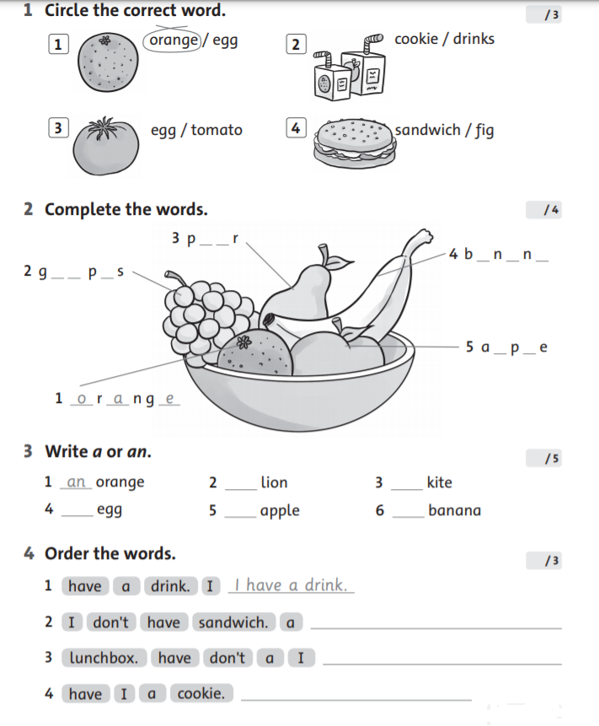**REVIEW 3**

**WEEK 34 GRADE2- Thursday, May 13th , 2021**

**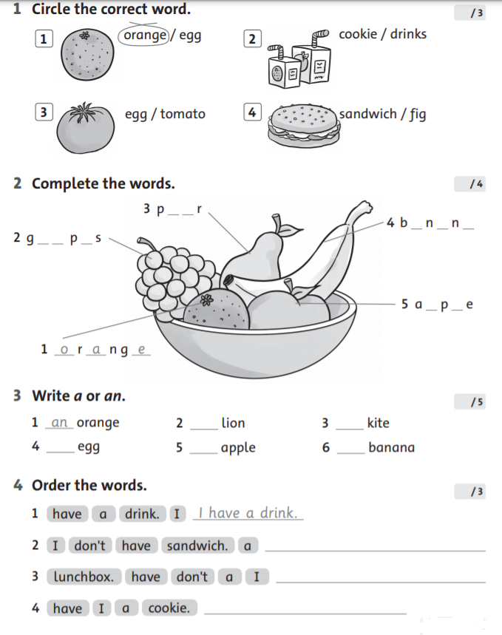****REVIEW 4**

**WEEK 34 GRADE2- Friday, May 14th , 2021**

**REVIEW 5**

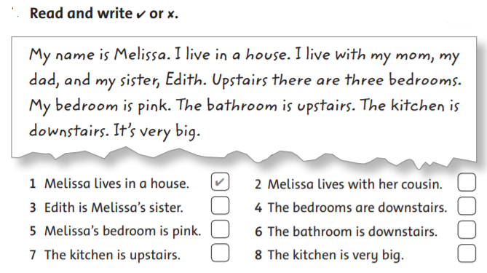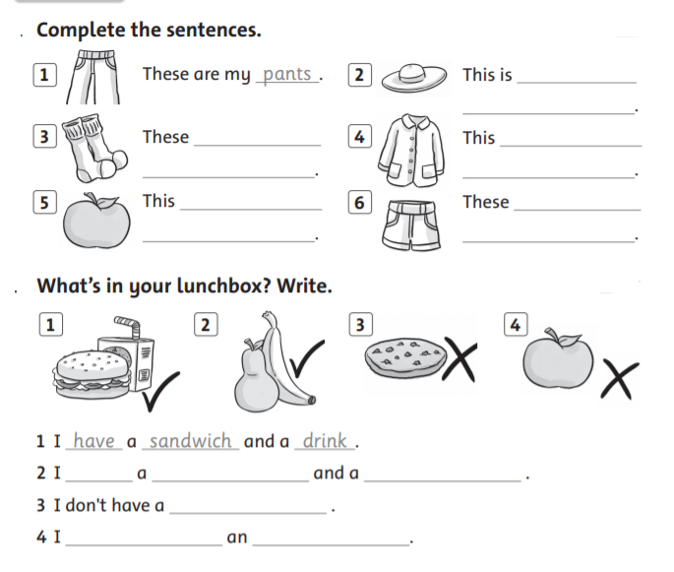

**1**

**2**

**3**